Charleston Day School
2020 Summer Reading List
Rising Second Graders
Dear Parents of Rising Second Graders,
Daily reading practice is a key component on the journey to independent reading! Please help your child keep a record of summer reading on the attached form. There is a recommended book list included, but please don’t feel limited to this list. Allow your child’s interests to direct his/her reading selections and encourage curiosity and exploration! Reading aloud to your child while modeling fluency and expression creates a positive reading experience, expands your child’s vocabulary, and encourages listening on a higher level. Picture books provide a rich visual experience for all ages. Please encourage your child to linger over the illustrations and look for context clues and visual messages that might not be included in the text (mood, style, setting, time period, etc.). With nonfiction, help your child recognize text features like headings, BOLD or italicized print, photograph captions, charts and graphs, table of contents, and glossary. These are key ingredients that help the reader understand the topic and the organization of the information presented.

A minimum of ten books is required, but more is encouraged! Please help your child select a mixture of fiction and nonfiction. Return the book log to your child’s teacher in August. We will use it with a fun activity the first week of school. Please help your child continue to develop the love of reading in a nurturing, low key, stress-free, summer atmosphere!
Many thanks,
Jane Bullard

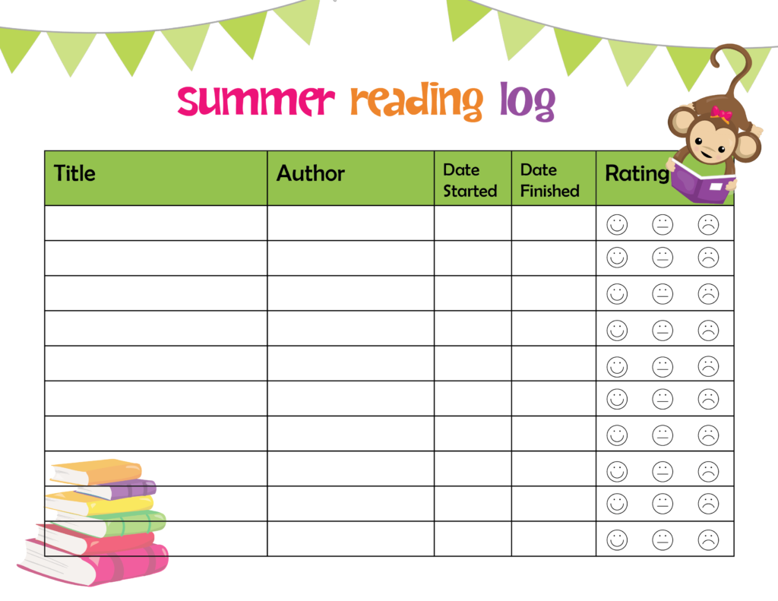

* Add more pages as needed
Second Grade Summer Reading List Suggestions:
Amal Alma and How She Got Her Name
By Juana Martinez-Neal

Born to Ride: A Story About Bicycle Face
By Larissa Theule

Brave Ballerina: The Story of Janet Collins
By Michelle Meadows

Can I Be Your Dog?
By Troy Cummings

The Day You Begin
By Jacqueline Woodson

Friends Stick Together
By Hannah E. Harrison

Giraffe Problems
By Jory John

Hidden Figures: The True Story of Four Black Women and the Space Race
By Margot Lee Shetterly

Love, Z
By Jessie Sima

The Magician’s Hat
By Malcolm Mitchell

Misunderstood Shark
By Ame Dyckman

Mixed: A Colorful Story
By Arree Chung

Pipsqueaks, Slowpokes, and Stinkers: Celebrating Animal Underdogs
By Melissa Stewart

Planting Stories: The Life of Librarian and Storyteller Pura Belpré
By Anika Aldamuy Denise

Remarkably You
By Pat Zietlow Miller

The Remember Balloons
By Jessie Oliveros

Rescue and Jessica: A Life-Changing Friendship Jessica Kensky and Patrick Downes

Shaking Things Up
By Susan Hood

Sleepy, the Goodnight Buddy
By Drew Daywalt

We Don’t Eat Our Classmates
By Ryan T. Higgins

More Choices:
Biographies
Adler, David A. A Picture Book of…series of biographies
Various Authors Ready-to-Read Childhood of Famous Americans
Various Authors Ready-to-Read Stories of Famous Americans
Various Authors Legendary Heroes of the Wild West
Various Authors Dorling Kindersley Readers – biography series
Various Authors Step-Into-Reading – biography series

Historical Fiction
Osborne, Mary Pope The Magic Treehouse series

Mysteries
Preller, James Jigsaw Jones series
Quackenbush, Robert M. Detective Mole series
Sobol, Donald J. Encyclopedia Brown series
Cole, Joanna The Magic School Bus series
Grolier’s Publishers Nature’s Children series
Ready-to-Read Pets to the Rescue series
Stevens, Gareth, Pub. The New Creepy Crawly Collection series
Secrets of the Animal World series
Animal Magic for Kids series
The Wonder of….animal series
Smithsonian Soundprints Read-and-Discover books
Backyard series
Oceanic Collection series
Various Authors All Aboard Science Readers
Various Authors Dorling Kindersley Readers

